Fzero Installation Guide

# Database

* Stop all windows services

1. ReportService
2. DailyReportService
3. WeeklyReportService
4. ClientReportService
5. CDRImportlService

* Stop all SQL jobs and generate scripts for

1. Daily Backup Job
2. Level One Compare Job

* Create backup of last database after
* Restore backup to new server
* Execute jobs scripts

# Create DB Email Profiles and Accounts

* Creating Database Email profiles:

1. Open Management folder after connecting to SQL service through SQL Server Management Studio.
2. Right click on Database Mail and choose Configure Database Mail
3. Then Choose Setup Database Mail …
4. Create 2 profiles with the following
5. FMS_Profile
6. FMS_Syria_Profile

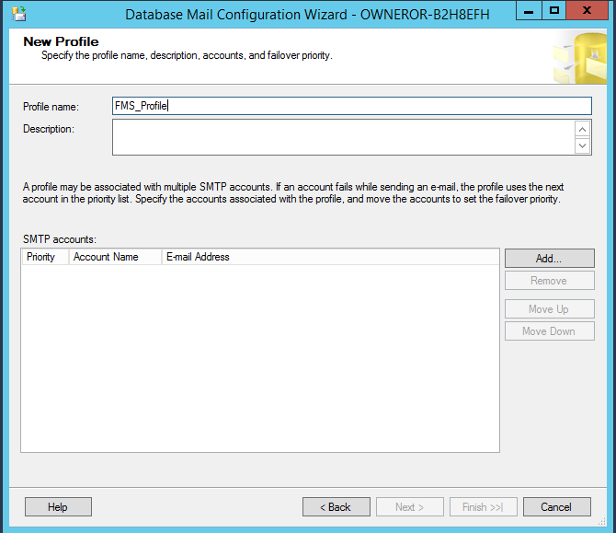

* Press Add account for each profile… and fill the accounts information for each, accounts are FMS_Account and FMS_Syria_Account.

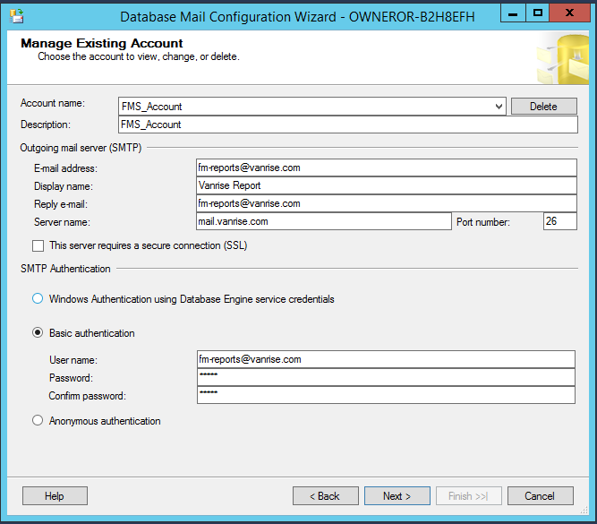

# Install prerequisite applications

* Install Telerik “Telerik.Web.UI_2012_1_215_Dev”

# Creating implementation directories

* Copy the zipped folder FMS_Import and extract it in C:\ Directory
* Create Folder FMS_Reports and save it in published version folder mentioned above
* You should give permission everyone: read/write on above folders

# Publishing on Website on IIS

1. Click Start, point to Settings, and then click Control Panel.
2. Double-click Administrative Tools, and then double-click Internet Services Manager.
3. Click Action, point to New, and then click Web Site.
4. After the Web Site Creation Wizard starts, click next.
   1. Type Name for the Web site **Fzero**.
   2. Application Pool: choose **DefaultAppPool**.
5. .Net CLR Version: 4.0
6. Managed Pipeline Mode: Integrated.
7. Identity: ApplicationPoolIdentity
   1. Either type the path to the folder that is holding the Web site documents or click Browse to select the published version folder, with the following path **C:\FMS\Pub**
   2. Select the IP address to use for the site.   
      **Select All** (unassigned), the Web site is accessible on all interfaces and all configured IP addresses.
   3. Type the TCP port number to publish the site on. **80**
   4. Type the Host Header name (**www.Fzero-vanrise.com**).
   5. Click Finish.

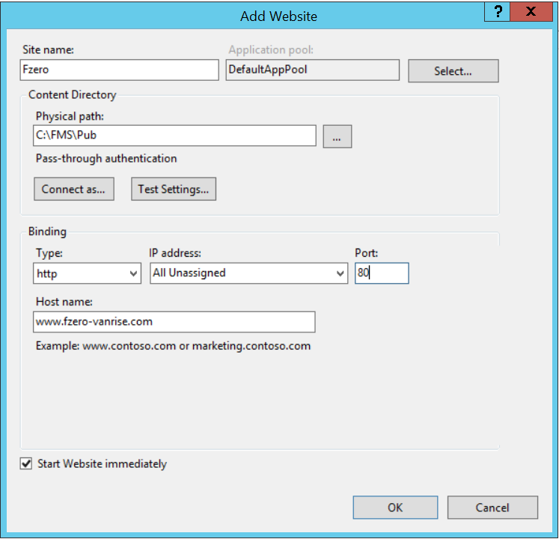

Note, you should make sure that the published version Web.config file has connection string with credentials that can access the database of this app called **FMS**

# Installing Windows Service

* Use the following step for each service :

1. Open cmd “run as administrator”
2. Run the following commands
3. cd C:\Windows\Microsoft.NET\Framework\v4.0.30319

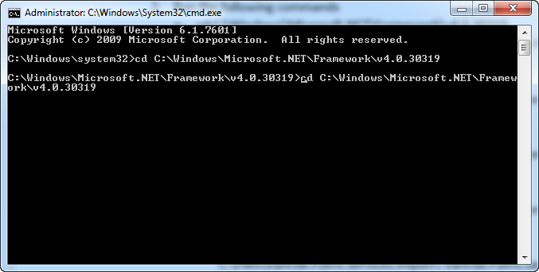

1. InstallUtil.exe "**Service Path**”, replace the service path with the paths provided bellow respectively for reach service.
2. **ClientReportService**:

C:\FMS\Vanrise.Fzero.Services.ClientReport\Vanrise.Fzero.Services.ClientReport.exe

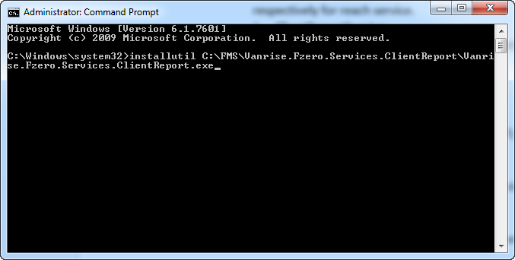

1. **DailyReportService**:

C:\FMS\Vanrise.Fzero.Services.DailyReport\ Vanrise.Fzero.Services.DailyReport.exe

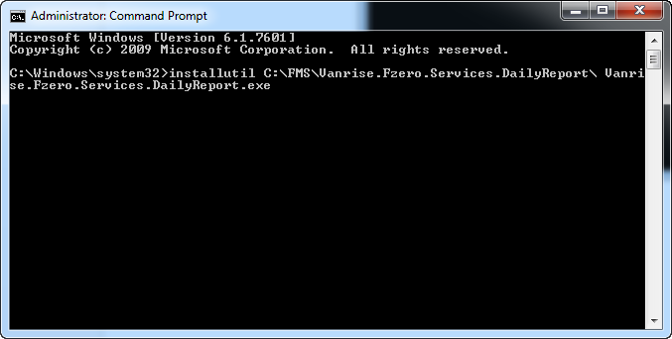

1. **CDRImportService**:

C:\FMS\Vanrise.Fzero.Services.Import\ Vanrise.Fzero.Services.CDRImport.exe

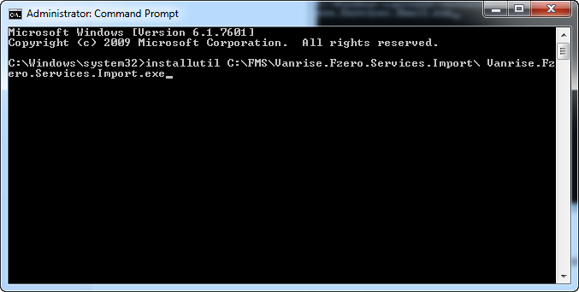

1. **RepeatedReportService**:

C:\FMS\Vanrise.Fzero.Services.RepeatedReport\Vanrise.Fzero.Services.RepeatedReport.exe

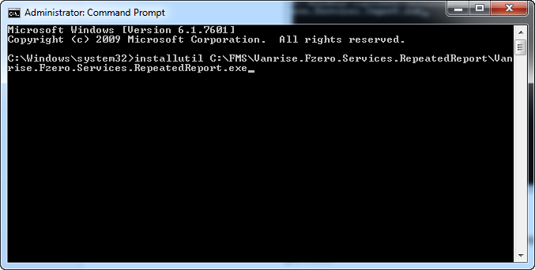

1. **ReportService**:

C:\FMS\Vanrise.Fzero.Services.Report\ Vanrise.Fzero.Services.Report.exe

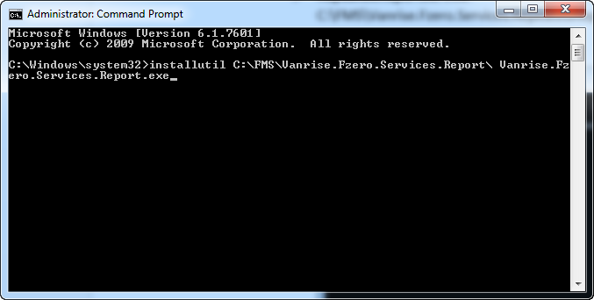

1. **WeeklyReportService**:

C:\FMS\Vanrise.Fzero.Services.WeeklyReport\Vanrise.Fzero.Services.WeeklyReport.exe

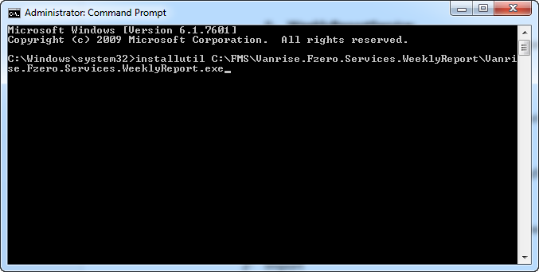

1. **MySQLService**:

C:\FMS\Vanrise.Fzero.Services.MySQL\Vanrise.Fzero.Services. MySQL.exe

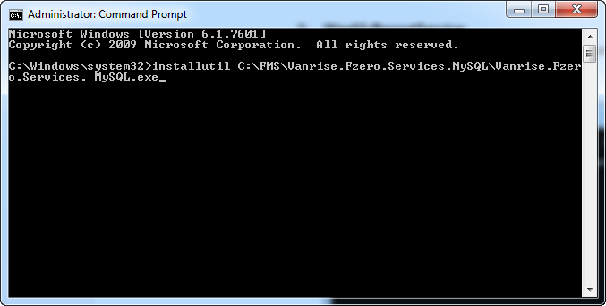

1. **ReceivedMySQLService**: C:\FMS\Vanrise.Fzero.Services.ReceivedMySQL\Vanrise.Fzero.Services. ReceivedMySQL.exe

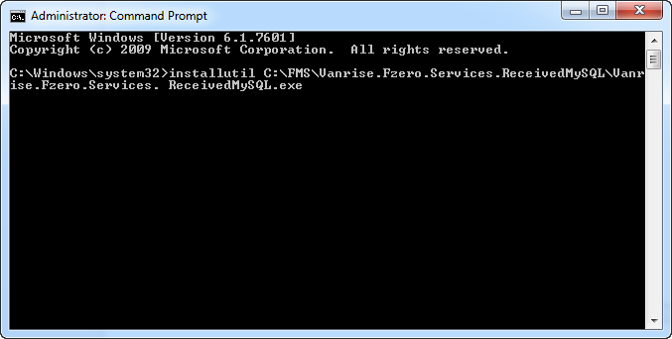

1. Services should be installed and started in the following order
2. CDRImport
3. Report Services: Report, Client, Daily, Weekly, Repeated
4. MySQL
5. Received MySQL
6. Note that the folders that contain the service should have permission read and write for everyone.